

CP5046 ICT Phase - 1

Assessment TASK 1: Project Documentation

**Lecturer: Laura Antochi**

**Team Members:**

Anastasia Verchak ID: 13446694

Charanpreet Kaur ID: 13543377

Harshitha Paderu ID: 13539782

## Project description and goals:

The primary goal of this project is to develop a responsive website with high efficiency, learnability, memorability and safety; for the staff, students/parents of the Russian language school- Romashka (Daisy).

The secondary goal is to create centralized solution for the marketing team of the school. Online-Presence is very crucial to any business these days in order to promote themselves. This website will trigger exactly this and will help in having all activities - general information, enrolment, fee payment, etc.; all under one roof. It will also contain hyperlinks to other social media accounts to reassure visitors of its presence and growth in real-time.

## Justification for the project

Information about the websites of schools that could be potential competitors to Romashka:

1. Most of the Russian language school websites are NOT responsive.

2. They provide different and lesser information on their English version when compared to more information on their Russian version.

3. No website has a login portal for staff/students.

4. No website has a SSL certificate and so are not be trusted.

5. No website meets the standard layout that all business websites follow these days.

The website that is going to be developed during this course will overcome all the above mentioned limitations. Also,

1. It will have no bias. It will provide same information in the English/ Russian version.

2. All contact details will be provided under a separate section of the website and also in the footer, i.e; phone number, email, social media links.

3. It will be responsive.

4. It will be secure.

5. It will be easy for visitors to understand and have proper sense of navigation throughout.

## Roles and Contributions:

|  |  |  |
| --- | --- | --- |
| **Name** | **Project role(s)** | **Individual contributions** |
| Anastasia Verchak | Project manager, tester | * Client agreement - Prototypes * Communication with client - Testing tools |
| Charanpreet Kaur | Developer | * Project tools * Milestones * Configuration management |
| Harshitha Paderu | Developer | * Justification - Milestone 1 (Learning tools) * Project Goals - Editing & Formatting |

**Project Timeline:**

**Milestone 1:**

|  |  |  |
| --- | --- | --- |
| User story | Priority | Time frame |
| Home page | 10 | 12/12/18 – 27/12/18 |
| Login page(student) | 10 |
| Login page(staff) | 10 |

|  |  |  |
| --- | --- | --- |
| **Developer’s Learning Tools** | **Priority** | **Time Frame** |
| Bootstrap (5 days) | 10 |  |
| Dreamweaver (5 days) | 10 |
| PHP (5 days) | 10 |

|  |  |  |
| --- | --- | --- |
| **Project Manager’s Learning Tools** | **Priority** | **Time Frame** |
| Project Management Tools (x days) | 10 |  |

**Milestone 2:**

|  |  |  |
| --- | --- | --- |
| User story | Priority | Time frame |
| Dashboard | 10 | 28/12/18 – 12/01/19 |
| Enrollment page | 10 |
| Payment page | 10 |

**Milestone 3:**

According to given timeline, the schedule looks little ambitious but, with combination of execution and communication we are sure that we can finish the project on time.

|  |  |  |
| --- | --- | --- |
| User story | Priority | Time frame |
| About Us page | 20 | 13/01/19 – 28/01/19 |
| Contact Us page | 20 |
| Blog(Admin) | 40 |
| Event page | 40 |
| Blog (visitor) | 50 |

## Project scope

Alpha-release

|  |  |  |  |
| --- | --- | --- | --- |
| **Title** | **Description** | **Client Priority** | **Time estimate (days)** |
| Login page (student) | Access to the profile for checking the study progress and upload a homework, paying fees and etc | 10 | 5 |
| Login page (staff) | Access to the profile, edit students, classes | 10 | 5 |
| Home page | Access to the whole web-site, main page with news, greetings and main menu | 10 | 5 |
| Registration page | Registration to the school | 10 | 3 |
| Dashboard | Student has an access to his study activities | 10 | 5 |
| Contact us page | Access to the contact details of the school to find its location, phone number for any queries. | 20 | 2 |
| About us page | Access to the information about the school involving teaching programs, events ,etc. | 20 | 5 |

Beta Release

|  |  |  |  |
| --- | --- | --- | --- |
| Title | Description | Client Priority | Time estimate (days) |
| Confirmation page | presents the total amount to be paid | 20 | 5 |
| Payment page | process the payment | 20 | 5 |
| Subject Selection page | Students can enroll by choosing the subjects for the first time and confirm their enrollment | 20 | 5 |
| Edit Selection page | Edit the choices of subjects (withdrawing, changing of subjects. | 20 | 5 |

Final-release

|  |  |  |  |
| --- | --- | --- | --- |
| Title | Description | Client Priority | Time estimate (days) |
| Blog(Admin) | Allows the admin to post articles about school that visitors can read. | 40 | 3 |
| Events Page | Allows visitors to check upcoming event details, and register if necessary | 40 | 1 |
| Blog(Visitor) | Allows visitors to read the blogs posted by the admin(like or dislike and comment on it) | 50 | 3 |
| Gallery | Allows all visitors to view images of school, events conducted,etc | 50 | 1 |

## Project sponsor

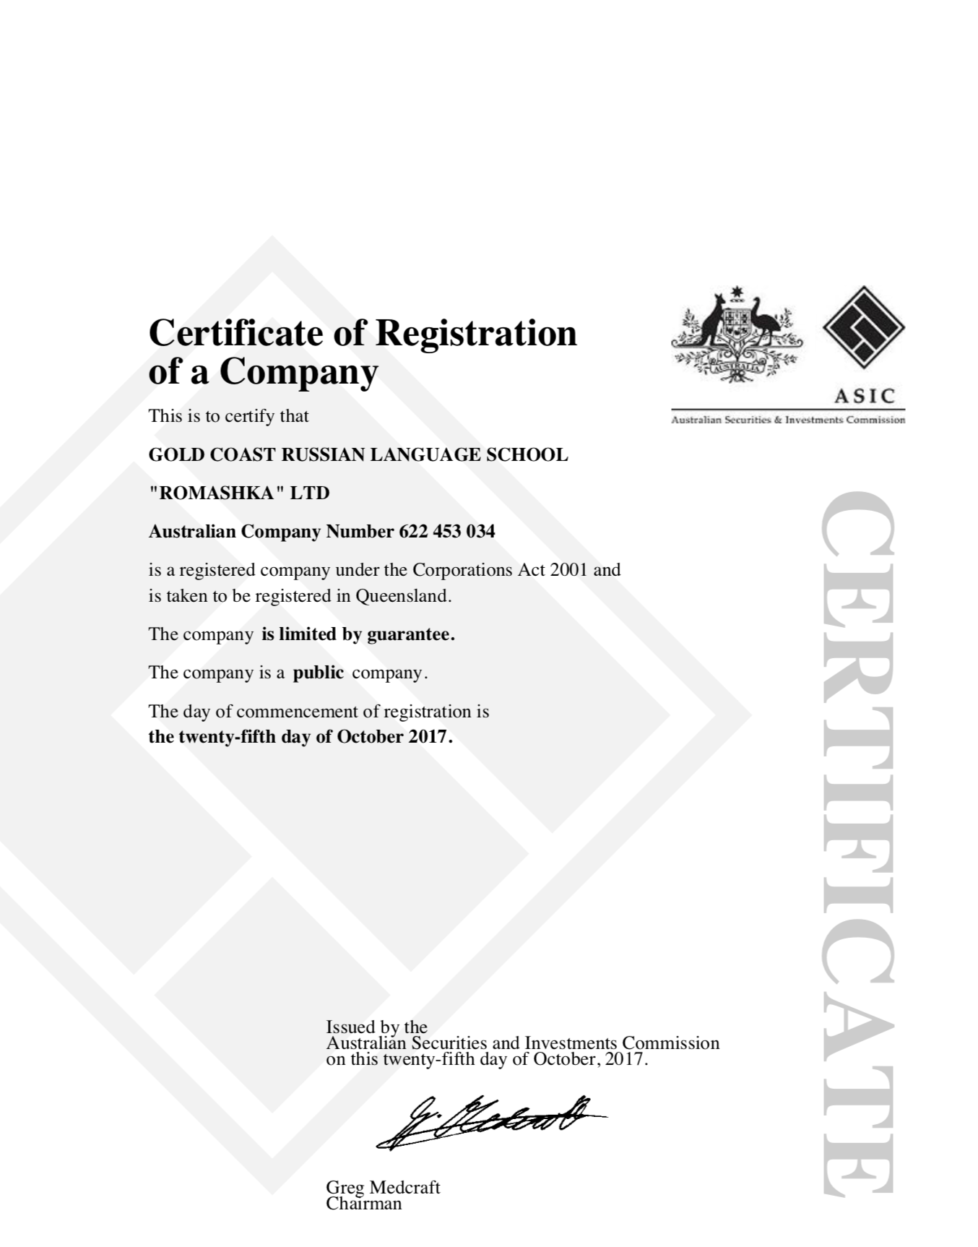

|  |  |
| --- | --- |
| **Name** | GOLD COAST RUSSIAN LANGUAGE SCHOOL  "ROMASHKA" LTD |
| **ABN** | 67622453034 |
| **Contact person** | Victor Ovchinnikov, principal |
| **Contact email** | [info@schoolromashka.com.au](mailto:info@schoolromashka.com.au) |
| **Contact phone** | 468296494 |

Client agreement is attached as Attachment 1.

## Configuration management

1. **GitHub:**

GitHub is an online version control service which stores our work in versioned fashion. We can revert to any version at any point in time. Multiple users can use a repository to store their work.

**Link to the repository is as follow:**

<https://github.com/harshup96/Romashka>

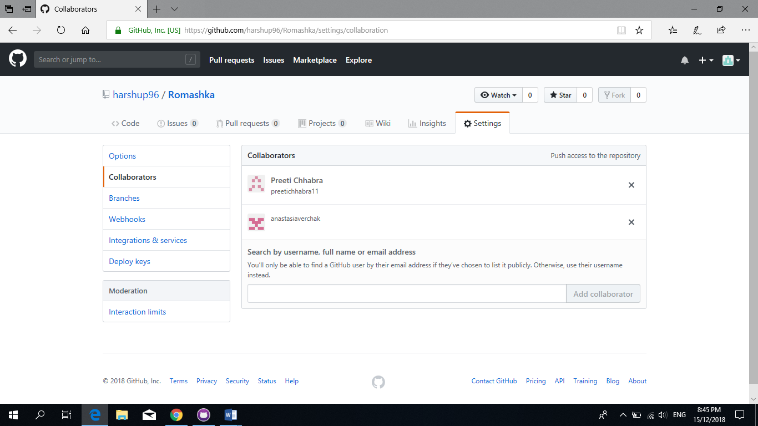

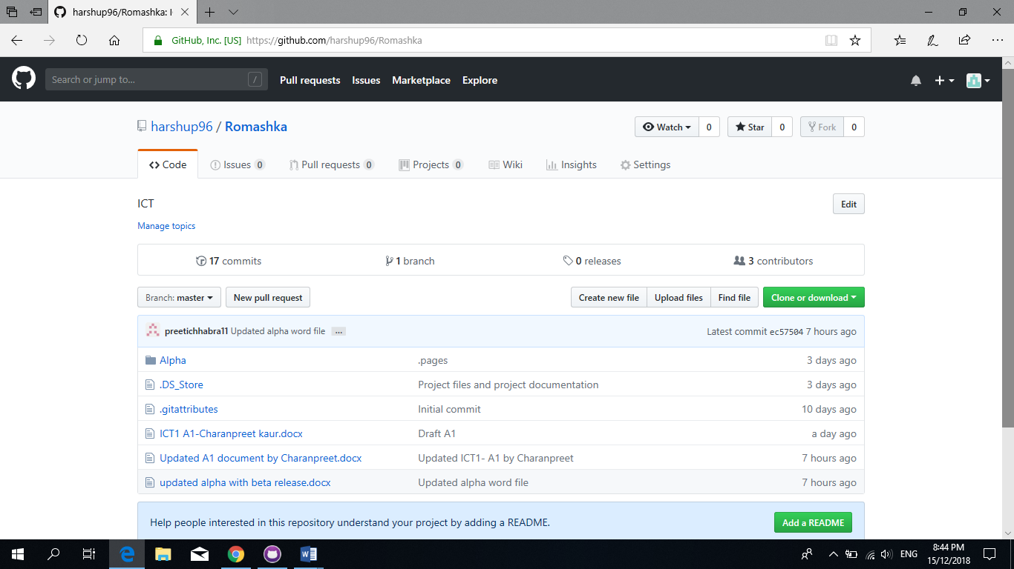

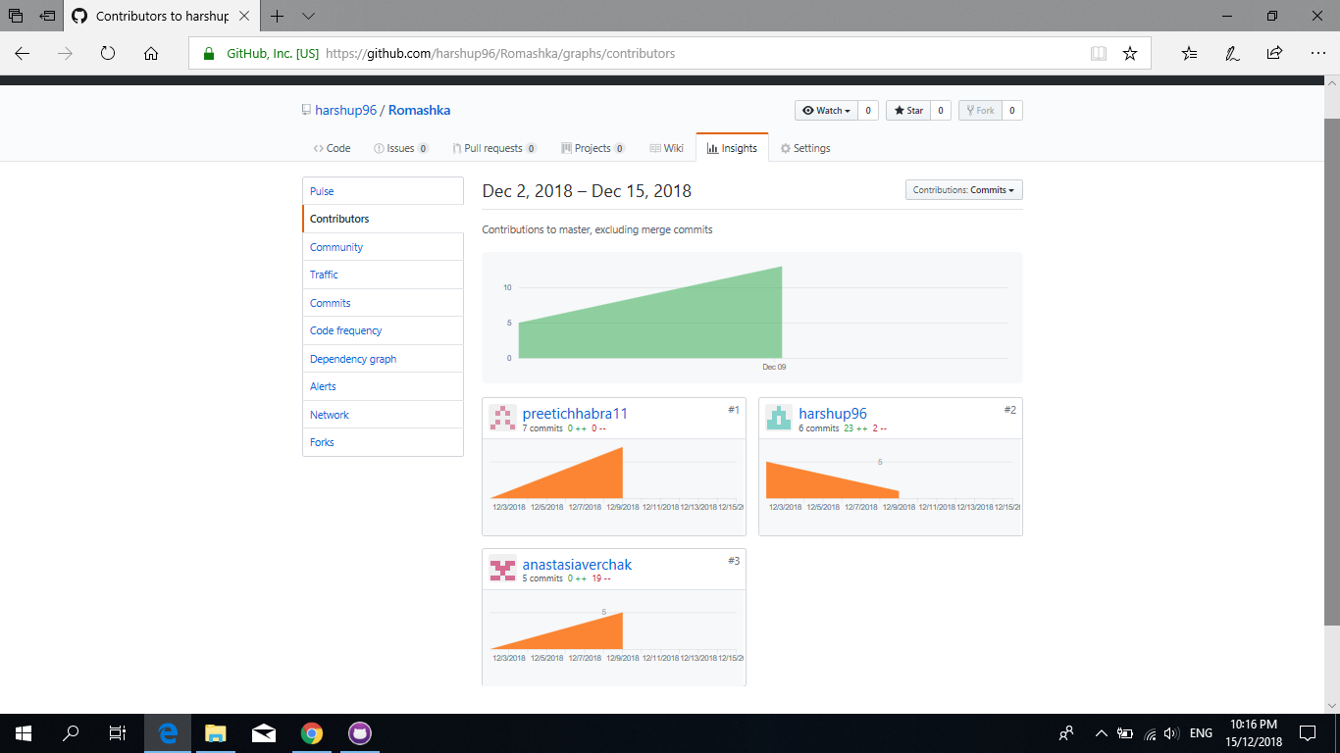

1. **Google Drive:**

Google drive is a cloud storage solution for Internet giant Google. We can use it to collaborate and work on documents simultaneously in real time. Initially, Google provides 15GB of free space and it can extended with subscription. We used Google Drive to share large files initially then, we started using git.

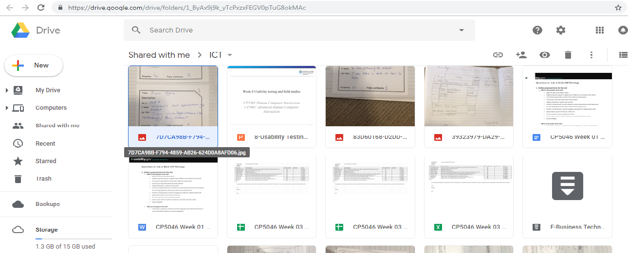

**Project Tools:**

1. **Adobe Dreamweaver:**

It is a comprehensive tool developed by Adobe for web designers. We used Dreamweaver for designing our HTML and CSS pages. The integration with Git makes it flawless. It also supports JavaScript, PhP.

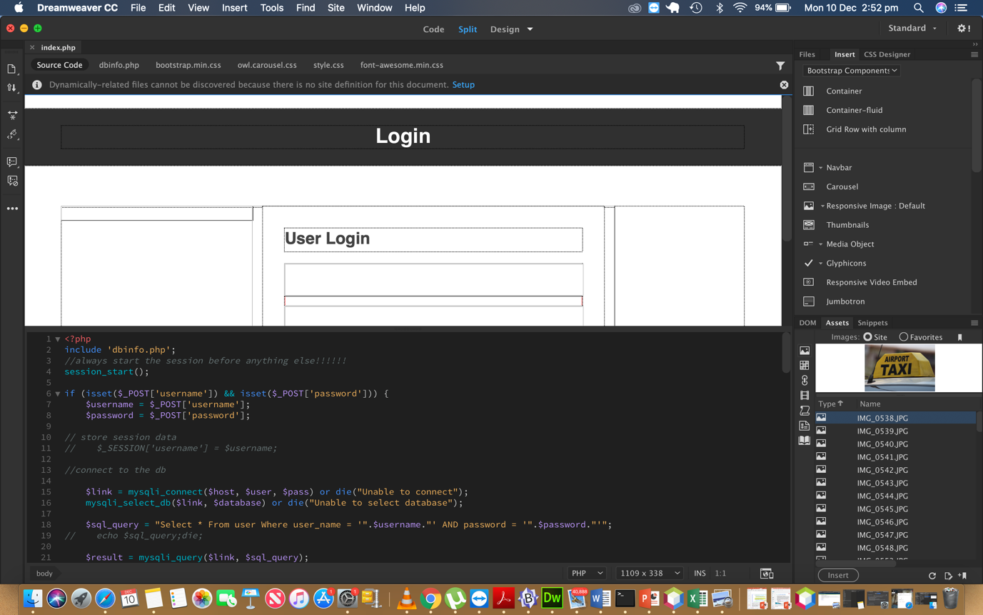

1. **PHP**:

PHP is a server side scripting language that is embedded in HTML. It is integrated

with number of popular databases like MySQL, Oracle, PostgreSQL, Informix, etc.

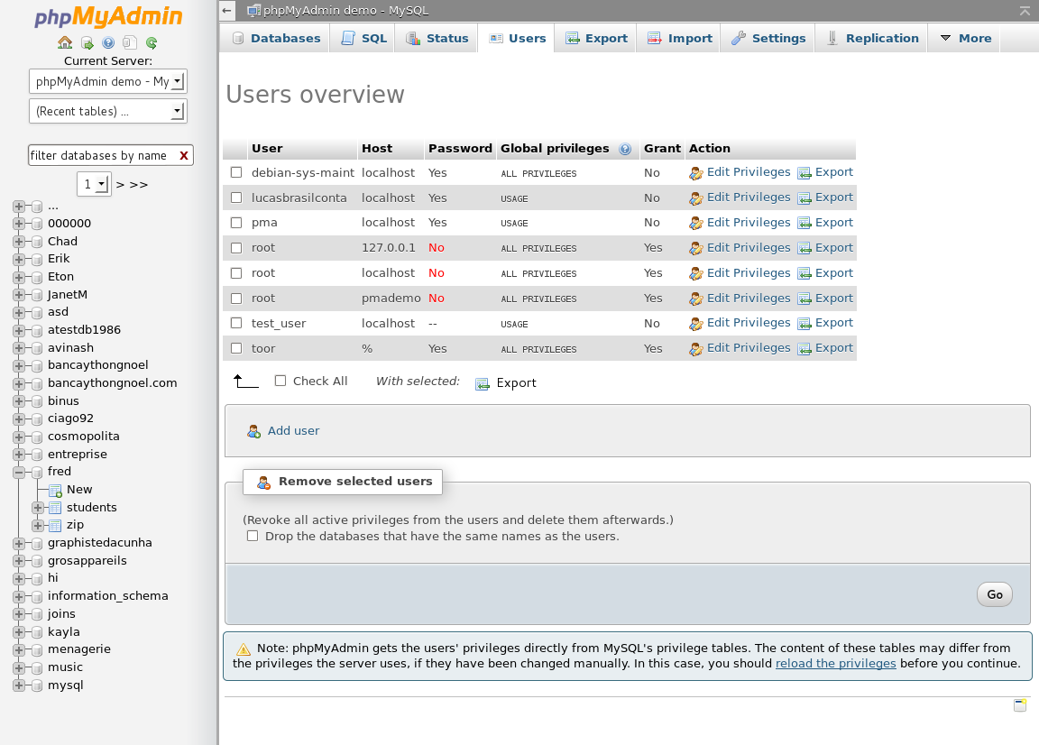

1. **HTML:**

HTML stands for Hypertext Markup Language. It supports tags for various elements of a web page.

1. **CSS:**

CSS is basically a styling language. It works in tandem with HTML for create beautiful webpages.



1. **MySQL**:

MySQL is a sequential programming language which helps in creating, managing and

retrieving data from databases. We are using Microsoft access to implement our

database.

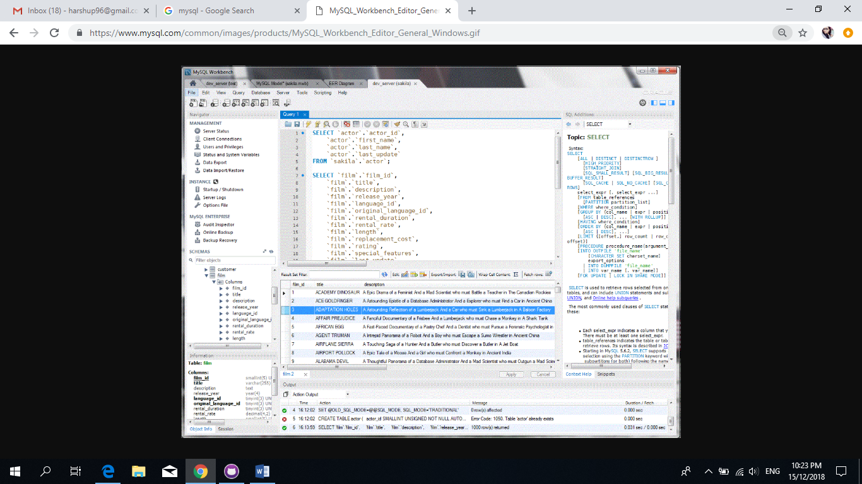

** If a new team member adds up in later phases, they have to install Dreamweaver, Access on their laptops. The previously developed versions can be found on GitHub. The new team member should understand our progress and be able to learn programming needed. He/she should be able to understand the user stories and priorities.

## Testing tools

All test cases are attached as Attachment 2.

|  |  |  |  |
| --- | --- | --- | --- |
| **Test case number** | **User story** | **Description** | **Testing type** |
| RLSR_001 | School login screen | Verify login with valid username and password | Manual, database testing |
| RLSR_002 | School home screen | Verify that domain name is working and home page is available | Manual, domain name testing |
| RLSR_003 | School registration screen | Verify that registration is working | Manual, database testing |
| RLSR_004 | About us screen | Page About us is available and readable | Manual |
| RLSR_005 | Student dashboard screen | Verify that dashboard is working | Manual |
| RLSR_006 | Logout function | Verify that user had been log out from the system | Manual |
| RLSR_007 | Contact us screen | Verify that Contact us page is working, text is readable, map is correct. | Manual |
| RLSR_008 | Enrolment page | Verify that Enrolment page is working | Manual, database testing |
| RLSR_009 | Payment page | Verify that Payment page is working | Manual, database testing |

## Prototypes

**User story: About us**

|  |
| --- |
|  |
| **User story: Contact us** |
| **User story: Blog (guest)** |
| **User story: Enrolment** |
| **User story: Dashboard** |
| **User story: Payment** |
|  |
| **User story: Event page** |
| **User story: Blog (add news)** |
|  |
| **User story: Registration** |
| **User story: Login page** |
|  |